**文献笔记**

Cultural tree preference and its influence on tree biodiversity in urban public spaces in Nanjing city, China (Zhang et al., 2020)

记忆标签：南京；文化。

调查南京200多个人工设计单元的树种，认为对有文化价值树种的偏爱是造成本地树种比例降低的一个要素。应该认识到本地树种和本地特有文化的价值。

Plant Diversity Along the Urban–Rural Gradient and Its Relationship with Urbanization Degree in Shanghai, China (Wang et al., 2020)

记忆标签：上海；城市化梯度；多种模式。

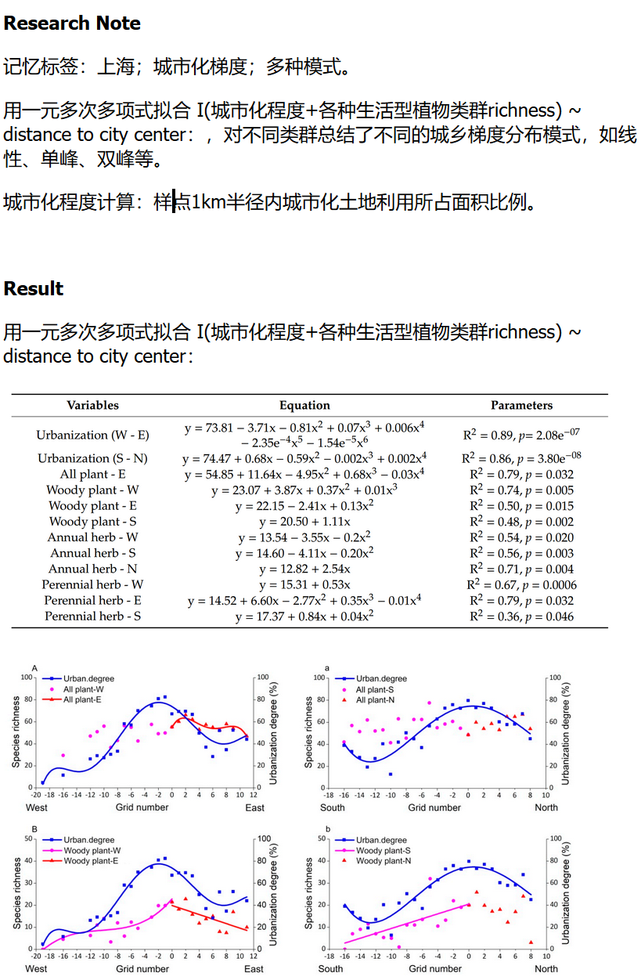

其他国内的符合中度干扰假说的研究：

This can be explained by intermediate disturbance

hypothesis or other urban-related disturbances, similar to previous studies in Chinese cities [14,92,93].

Predicting Opportunities for Greening and Patterns of Vegetation on Private Urban Lands

记忆标签：巴尔的摩；社会学

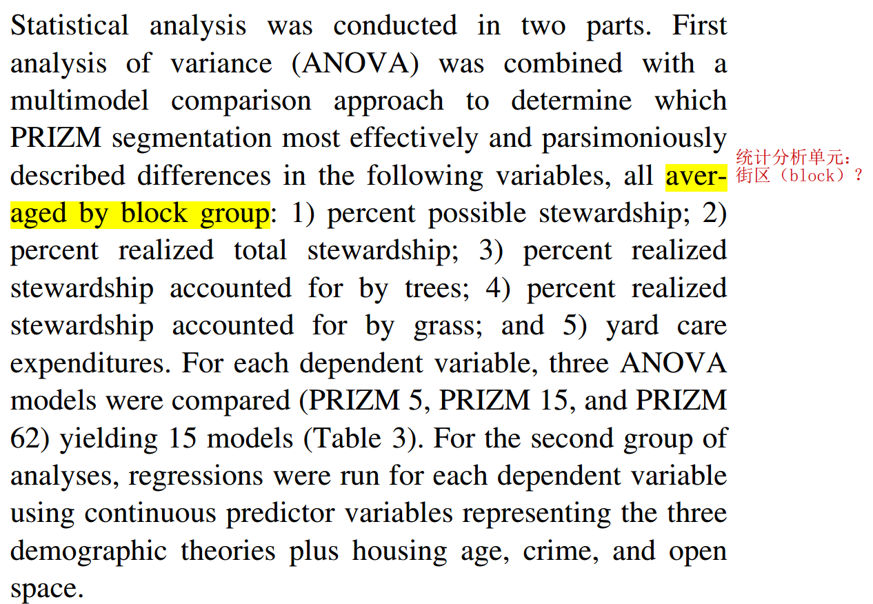

**一些需要搞清楚的问题**

公共地区的植物多样性一般低于私人住宅？

如何量化“城市化尺度”：

最早的“到城市中心的距离”被认为太宽泛，后来有其他量化方法：

城市化程度计算：样点1km半径内城市化土地利用所占面积比例(Wang et al., 2020)；

德尔菲法；

index

Despite its relevance, this variable should be complemented by other metrics for a more accurate description of urban biodiversity (Farinha-Marques et al., 2011) like evenness, distribution, abundance and variation indices.

not just because of their basal position in food chains, but also owing to their importance for nesting and shelter{Farinha-Marques, 2011 #50}

. Luck et al. (2009) and Boone

et al. (2010) document legacy effects for woody plant cover in Australian country towns and tree cover in Baltimore respectively, with

the Baltimore study showing that past socioeconomic conditions

are better predictors than present conditions, (Kirkpatrick et al., 2011)

In Guangzhou, China, Jim and Liu (2001b)

found that the most important ecological amenity in roadsides

was shade, while in parks it was flower or fruit provision,

demonstrating that different areas are managed to provide

different functions {Avolio, 2015 #107}.

even in tropical cities, nurseries are the source of most residential plants (Torres‐Camacho et al. [2016](https://esajournals.onlinelibrary.wiley.com/doi/full/10.1002/ecm.1290#ecm1290-bib-0046)). As Thompson et al. ([2003](https://esajournals.onlinelibrary.wiley.com/doi/full/10.1002/ecm.1290#ecm1290-bib-0045)) and Pincetl et al. ([2013](https://esajournals.onlinelibrary.wiley.com/doi/full/10.1002/ecm.1290#ecm1290-bib-0040)) point out, plant nurseries serve as an enormous species pool for urban trees, though the linkages between the horticultural trade and urban tree community assembly is still understudied. {Avolio, 2018 #110}

Most likely these relationships are driven by residents relying on local nursery stock and advice in tree selection as well as nurseries responding to customer preferences (Safley and Wohlgenant [1995](https://esajournals.onlinelibrary.wiley.com/doi/full/10.1002/ecm.1290#ecm1290-bib-0041), Hooper et al. [2008](https://esajournals.onlinelibrary.wiley.com/doi/full/10.1002/ecm.1290#ecm1290-bib-0018), Jin et al. [2013](https://esajournals.onlinelibrary.wiley.com/doi/full/10.1002/ecm.1290#ecm1290-bib-0026)).{Avolio, 2018 #110}

To have a comprehensive understanding on urban biodiversity and impact factors, a primary and rough systematic literature review was conducted with ISI Web of Science peer reviewed academic article database as the first step, in which, I used “socio” AND “urban” AND “biodiversity” as searching keywords for article topic, which is not comprehensive enough for my research topic for now though.

Most of the study conducted in EU and North America(Kowarik 2011), while less attention was paid to Asian countries under rapid urbanization process.

**1.1 SEM vs. Plant Diversity**

**Influence factors for urban plant diversity**

As a result, urban flora diversity, as a unique ecosystem component, is influenced both by biophysical and human drivers. It has been found that urban flora diversity is related to many factors related to human activities: (1) socio-economic drivers including housing age media income and population density; (2) design drivers including: area and impervious area; (3) preference of resident(Avolio, Pataki et al. 2018).

The research of socio-economic factors and plant diversity mainly occurs in the cities of developed countries, which are mainly capitalist countries(?). And it’s predicted that luxury effect may be reduced in more socialist cities, because the income inequality is reduced and urban planning is more focused on the equity regarding resources allocation(Leong, Dunn et al. 2018). Though luxury effect was also found in some research in city of socialist country, for instance, Wang et.al tested the relationship between housing price and plant diversity in Beijing, the different in strength of luxury effect between such city and the cities of other institute haven’t been tested(Wang, Qureshi et al. 2015).

**1.2 Socio-economic Factors vs. Plant Diversity**

Urban plant diversity is significantly determined by socio-economic factors. The research of Hope et.al in Central Arizona–Phoenix shows that family income and housing age best explained the plant diversity across the city rather than geomorphic factors (which is called “luxury effect”)(Hope, Gries et al. 2003). And the factors under luxury effect was tested or assumed to be(Leong, Dunn et al. 2018): (1) private properties: area of private green spaces and gardens, and the way residents manage their private green spaces is influenced by their income, wealthier people have more disposal resources for that; (2) neighborhood choice: people with high income choose to live in the habitat favor high biodiversity, and that in return, the competition of living here increases the property value; (3) legacy effects; (4) environmental context and regional differences. However, the condition of which luxury effect happens remains unclear, and the mechanisms driving the luxury effect haven’t been teased apart(Leong, Dunn et al. 2018).

句式

The native plant species richness did not show an evident pattern along any of the four urban–rural transects (Figure 5A,a) (Wang et al., 2020)

Avolio, M. L., D. E. Pataki, T. L. E. Trammell and J. Endter-Wada (2018). "Biodiverse cities: the nursery industry, homeowners, and neighborhood differences drive urban tree composition." Ecological Monographs **88**(2): 259-276.

Farinha-Marques, P., J. Lameiras, C. Fernandes, S. Silva and F. Guilherme (2011). "Urban biodiversity: a review of current concepts and contributions to multidisciplinary approaches." Innovation: The European Journal of Social Science Research **24**(3): 247-271.

Hope, D., C. Gries, W. Zhu, W. F. Fagan, C. L. Redman, N. B. Grimm, A. L. Nelson, C. Martin and A. Kinzig (2003). "Socioeconomics drive urban plant diversity." Proceedings of the national academy of sciences **100**(15): 8788-8792.

Kowarik, I. (2011). "Novel urban ecosystems, biodiversity, and conservation." Environ Pollut **159**(8-9): 1974-1983.

Leong, M., R. R. Dunn and M. D. Trautwein (2018). "Biodiversity and socioeconomics in the city: a review of the luxury effect." Biology letters **14**(5): 20180082.

Wang, H.-F., S. Qureshi, S. Knapp, C. R. Friedman and K. Hubacek (2015). "A basic assessment of residential plant diversity and its ecosystem services and disservices in Beijing, China." Applied Geography **64**: 121-131.